**Setup Node.js on Windows machine**

## Steps to install

### Step 1. Download the Node.js installer

- Go to https://nodejs.org/en/download/ and download the installer for windows.

- "LTS" a.k.a "long term support" means this version will be actively maintained by the team for a reasonable amount of time.

### Step 2. Launch the installer and follow the instructions

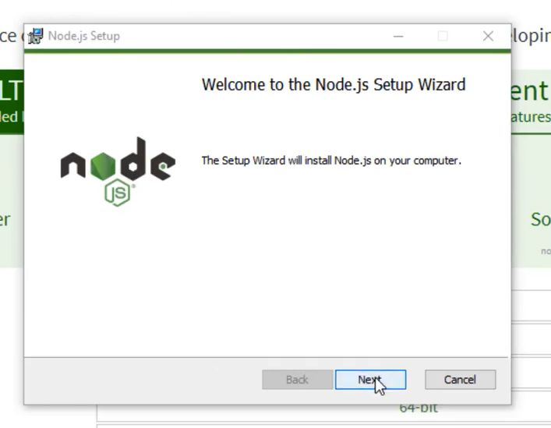

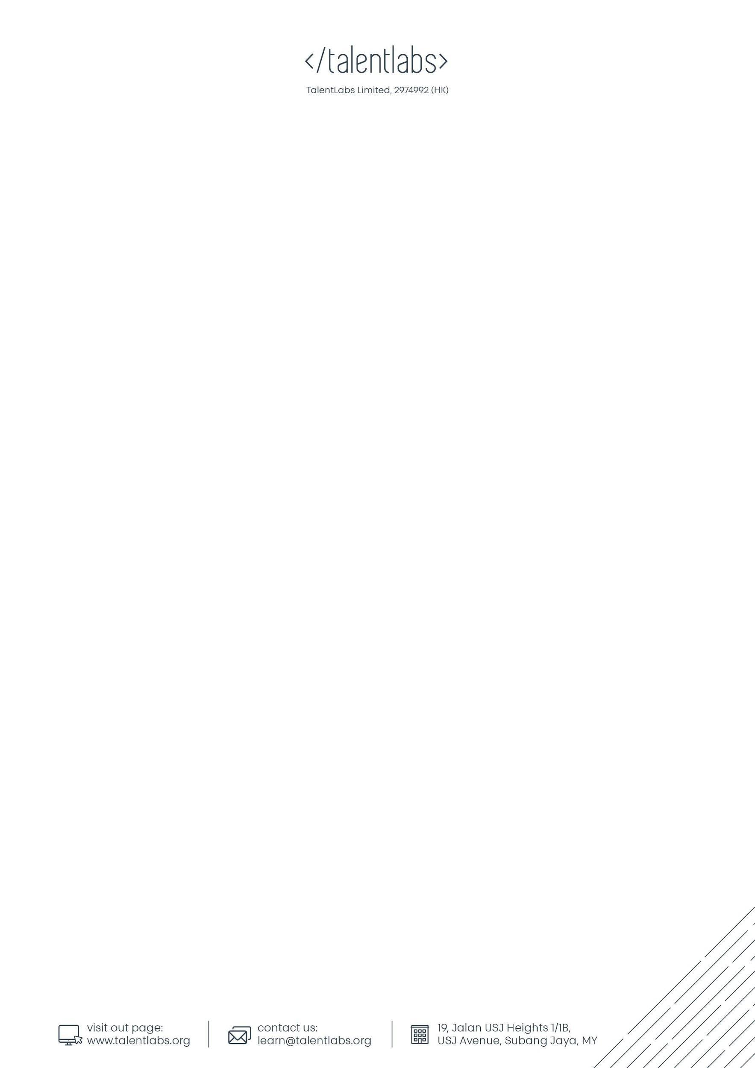

You can leave the options as is.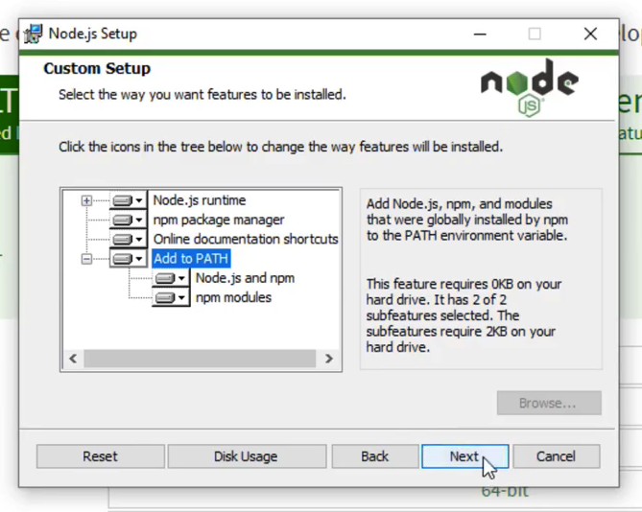

Make sure to check this option otherwise you might need additional steps later.

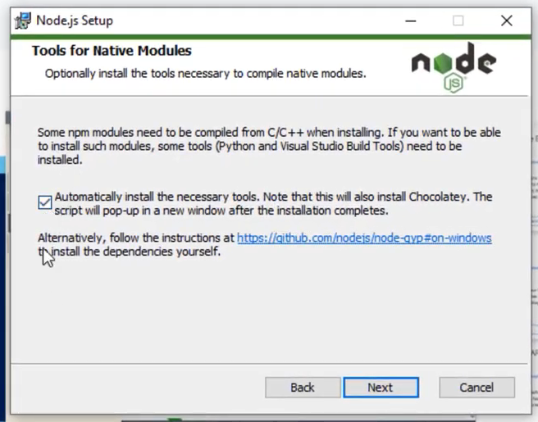

Click "Finish" to continue the next step.

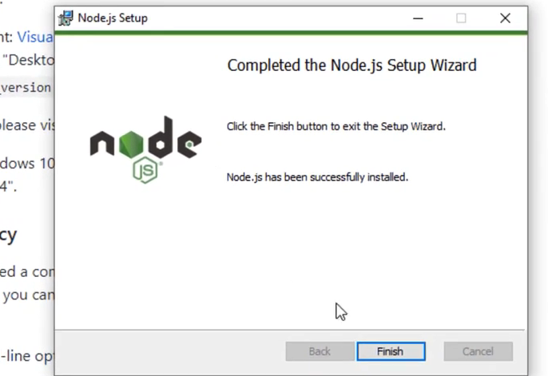

A command prompt as below should show up and you can press any key on the keyboard to continue. During this part, you may see more windows opened like PowerShell.

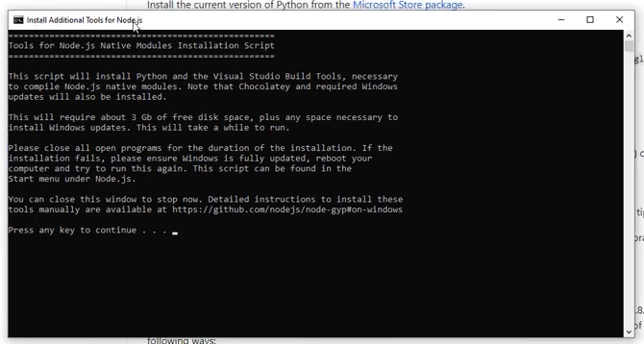

### Step 3. Verify the installation

- Open Powershell software

- Type `node -v`

- It should print the installed version number of Node.js